Classified Staff Meeting Minutes
May 22, 2024 | Teams | 1:00pm

Attendees:
Chairperson Mary Jo Rutherford, Jama Marshall Roy, Annette Shaw, Juanita Nickerson, Chip Hawkins, Don Luketic, Jaden Dent, Memori Dobbs

- Call to Order
Chairperson Mary Jo Rutherford called the meeting to order.

- Old Business
  - Motion to approve April Meeting Minutes
    - Annette requested a correction to Christy suggested to purchase blazers from JC Penney and have the logo added.
    - Juanita made a motion to approve March’s minutes. Chip seconded the motion. The motion was carried.
  - Congratulations to Jaden Dent for being selected as Employee of the Year!

- New Business
- BOG Report – Juanita Nickerson
  - Juanita was unable to attend the last meeting.
  - A pay raise was approved.
  - Next BOG Meeting is June 20th
- ACCE Report – Chip Hawkins
  - Funding for PEIA has increased
  - Benchmarking jobs/descriptions
  - Looking into pay structures to update salaries
  - 20% of the 10.5 increase on employee shoulders
  - Nothing has been approved yet
- Committee Reports
  - Legislative Affairs
    - No updates
  - Staff Development – Jama Marshall Roy
    - Reminder that Dr. Clemens’s Summer Training Series begins Monday, June 3rd at 9:30am in the President’s Conference Room (Room201A) at the ATC and every other week through the summer.
  - Website
    - Mary Jo has kept up with Matt Turner who has posted the latest approved meetings.
  - Special Events
    - No updates
  - Scholarship fund applications are due on June 28th.

  - Upcoming Meeting Dates 2024-2025
- July – No Meeting
- August 28, 2024
- September 25, 2024
- October 23, 2024
- November 20, 2024
- December 18, 2024
- January 22, 2025
- February 26, 2025
- March 26, 2025
- April 23, 2025
- May 28, 2025
- June 25, 2025

- Upcoming Meeting
The next meeting will be held on June 26th, 2024 @ 1:00PM via Teams.

Chip made a motion to adjourn the meeting. Memori seconded the motion. The motion was carried.

The meeting was adjourned.

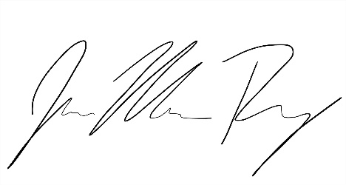
Respectfully submitted,

Jama Marshall Roy
Secretary

